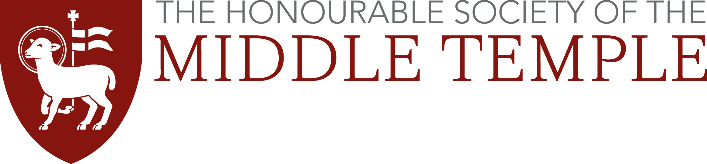
Anglo American Scholarship Application Form 2017

Please type in the boxes below using Arial font size 11 pt. Do not complete by hand. This application must be submitted by 27th January 2017.

Title
First name
Middle names (s)
Surname
Telephone number
Email address
Middle Temple
membership number
Call date (if applicable)
Please explain why you are applying for the scholarship and why it should be awarded to you. Max 250 words.

I hearby submit my application (including CV and academic reference) for the above named scholarship. I declare that the information I have provided is true in all respects.

Signature ……………………………………………………………

Date ………………………

(If this application is submitted by email, by doing so you confirm that the above declaration is true)

The information contained in your application will be processed and held in accordance with the Inn’s data protection policy.

